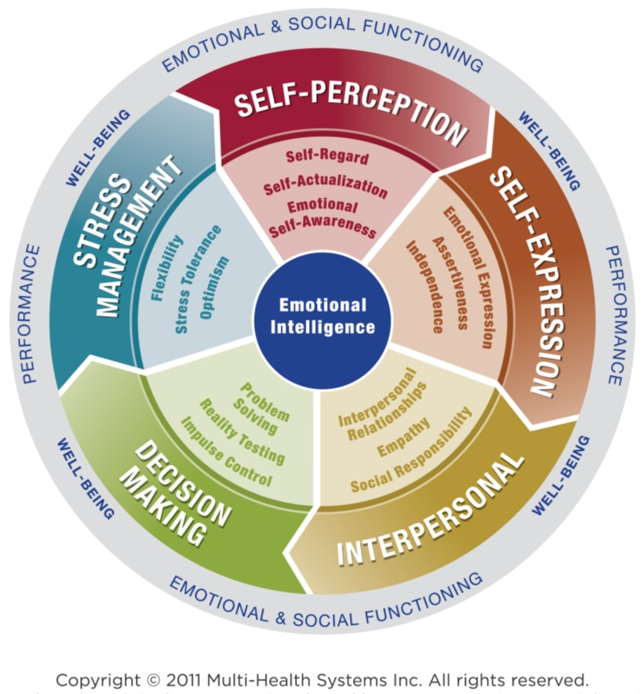

First Edition © 2018 Linda Comerford

Presented by

Comerford Consulting

6314 Onyx Circle

Indianapolis, IN 46237  
Mobile: 317-696-4444

Phone and Fax: 317-786-6404

Email: linda@comerfordconsulting.com

Website: www.comerfordconsulting.com

by Linda Comerford

**Exploring Emotional Intelligence**

#### EMOTIONAL INTELLIGENCE COMPOSITES

When you hear the term “Emotional Intelligence,” what comes to mind?

|  |
| --- |
|  |
|  |
|  |
|  |

**Definition:** As you can see from this exercise, you now have some idea about what Emotional Intelligence is NOT.

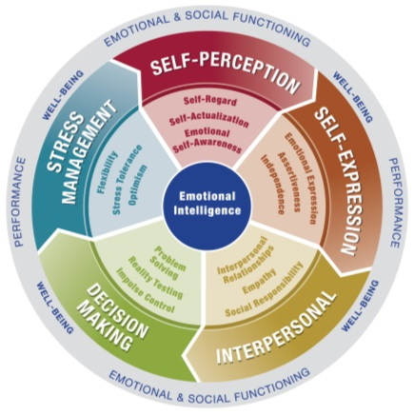

Here’s what Emotional Intelligence actually IS: A set of emotional and social skills that influence the way we perceive and express ourselves, develop and maintain social relationships, cope with challenges, and use emotional information in an effective, meaningful way.

You’re about to take a fascinating journey throught the 5 composites of Emotional Intelligence with me as your tour guide Your roadmap for your journey is the EQ-i 2.0 Emotional Intelligence Model. Notice how the 5 composites revolve around a wheel that colorfully displays them for you.



Let your journey begin!

**Self-Perception:** Your journey starts with YOU, which includes both your strengths and opportunities   
for improvement. Explore YOU and what you’d like to do on your journey before you set out on it.

**Self-Expression:** Once you know more about YOU, consider how you come across **to** others. Just as you have travel options like cars, buses, trains, boats, or planes, you also have a variety of communication styles you can use to make a favorable impression on others.

**Interpersonal:** It’s not just YOU on your journey because you’re sure to travel with or encounter others along the way. Consider how you interact **with** and communicate **with** your fellow travelers throughout your journey.

**Decision Making:** Decision making includes those forks in the road, construction delays, or frustrating detours we all face during our journeys. The best ways to handle them involve decisions you make along the way.

**Stress Management:** Stress can derail every aspect of your journey. It can start as you head out and continue through travel delays, accommodation mix-ups, and all the other mishaps that leave you too stressed to enjoy the journey or even celebrate when you reach your destination.

These 5 composites each include 3 related Emotional Intelligence skills. Your journey will continue with practical tips, techniques, and strategies for an enjoyable training trip toward your destination of a more emotionally intelligent YOU!

#### EMOTIONAL INTELLIGENCE SKILLS

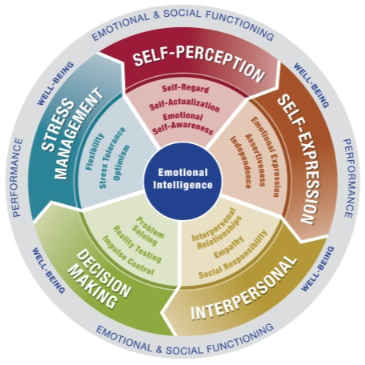

#### Exploring emotional intelligence

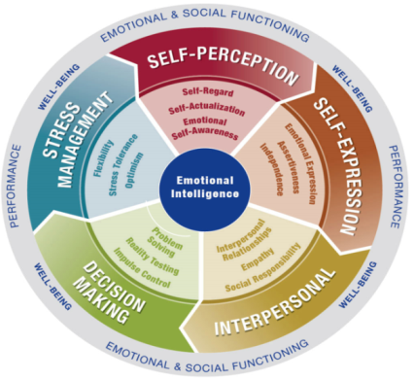

**Self-Regard** is respecting oneself while understanding and accepting one’s strengths and weaknesses. Self-Regard is often associated with feelings of inner strength and self-confidence.

**Self-Actualization** is the willingness to persistently try to improve oneself and engage in the pursuit of personally relevant and meaningful objectives that lead to a rich and enjoyable life.

**Emotional Self-Awareness** includes recognizing and understanding one’s own emotions. This includes the ability to differentiate between subtleties in one’s own emotions while understand the cause of these emotions and the impact they have   
on one’s own thoughts and actions and those of others.

**SELF-PERCEPTION**

**Emotional Expression** is openly expressing one’s feelings verbally and non-verbally

**Assertiveness** involves communicating feelings, beliefs, and thoughts openly,   
and defending personal rights and values in a socially acceptable, non-offensive, and non-destructive manner.

**Independence** is the ability to be self-directed and free from emotional dependency on others. Decision making, planning, and daily tasks are completed autonomously.

**SELF-EXPRESSION**

**Interpersonal Relationships** refers to the skill of developing and maintaining mutually satisfying relationships that are characterized by trust and compassion.

**Empathy** is recognizing, understanding, and appreciating how other people feel. Empathy involves being able to articulate your understanding of another’s perspective and behaving in a way that respects others’ feelings.

**Social Responsibility** is willingly contributing to society, to one’s social groups, and generally to the welfare of others. Social Responsibility involves acting responsibly, having social consciousness, and showing concern for the greater community.

**INTERPERSONAL**

**STRESS MANAGEMENT**

**Flexibility** is adapting emotions, thoughts,   
and behaviors to unfamiliar, unpredictable,   
and dynamic circumstances or ideas.

**Stress** **Tolerance** involves coping   
with stressful or difficult situations   
and believing that one can manage   
or influence situations is a positive   
manner.

**Optimism** is an indicator of one’s   
positive attitude and outlook on life.   
It involves remaining hopeful and   
resilient despite occasional setbacks.

**DECISION MAKING**

**Problem Solving** is the ability to find solutions to problems in situations where emotions are involved. Problem solving includes the ability to understand how emotions impact decision making.

**Reality Testing** is the capacity to remain objective by seeing things as they really are. This capacity involves recognizing when emotions or personal bias can cause one to be less objective.

**Impulse Control** is the ability to resist or delay an impulse, drive, or temptation to act and involves avoiding rash behaviors and decision making.



cid:image001.png@01D42B09.C77D6190

#### Self-perception

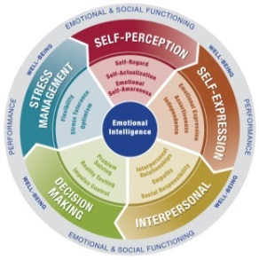

**SELF- PERCEPTION: Emotional Self-Awareness**

**Definition:** Recognizing and understanding your own emotions, their causes, and their   
 impact on you and others.

**Exploring Three EQ-i Insights:**

1. Self-Awareness is the **foundational** skill for the other14 skills.
2. As you journey toward understanding how you relate to all 15 skills, take a quiet moment to explore   
   your usage of them. There are no right or wrong, good or bad answers. It’s all about **frequency** of use.
3. Your ultimate goal is to achieve **balance** among as many skills as possible.

**Exercise:** Exploring YOU!Using a scale of 1-5, rate how often you use each skill below.

1 = Never/Rarely 2 = Occasionally 3 = Sometimes 4 = Often 5 = Always/Almost Always

**SELF-PERCEPTION**

**Self-Regard:** Respecting and accepting your strengths and weaknesses; level of comfort for what you know about yourself, warts and all.

**Emotional Self-Actualization:** Improving yourself and pursuing meaningful objectives with drive, passion, and purpose.

**Emotional Self-Awareness:** Recognizing and understanding your own emotions, their causes, and   
their impact on you and others.

**SELF-EXPRESSION**

**Emotional Expression:** Expressing your feelings openly and clearly, both verbally and non-verbally.

**Assertiveness:** Communicating feelings, beliefs, and thoughts; defending personal rights and values   
in a socially acceptable way; being direct with respect.

**Independence:** Acting with self-direction, free of emotional dependency on others; planning,   
making decisions, and completing daily tasks autonomously.

**INTERPERSONAL**

**Interpersonal Relationships:** Developing and maintaining mutually satisfying relationships   
characterized by trust and compassion; moving toward win/win results.

**Empathy:** Recognizing, understanding, appreciating, respecting, and articulating how others feel.

**Social Responsibility:** Contributing to society and showing concern for the welfare of others.

**DECISION MAKING**

**Problem Solving:** Finding solutions where emotions are involved; understanding how emotions impact decision making and using them productively.

**Reality Testing:** Remaining objective and seeing things as they really are; recognizing when and how emotions or personal bias can affect objectivity.

**Impulse Control:** Resisting or delaying an impulse to act; avoiding rash behaviors and decision making.

**STRESS MANAGEMENT**

**Flexibility:** Adapting your emotions, thoughts, and behaviors to unfamiliar, unpredictable, and changing circumstances or ideas.

**Stress Tolerance:** Coping with stressful or difficult situation; believing you have the ability to influence situations positively.

**Optimism:** Remaining hopeful and resilient with a positive attitude and realistic outlook on life despite occasional setbacks.

#### Self-expression

##### 

**SELF EXPRESSION: Emotional Expression**

**Definition:** Expressing your feelings openly and clearly, recognizing the impact of your   
emotions as you do so verbally and non-verbally, internally and externally.

**Exploring Three EQ-i Insights:**

1. What percentage of your interaction impact comes from the Three V’s?

|  |  |
| --- | --- |
| Your Guess? (Total = 100%) | Research Reveals: (Total = 100%) |
|  |  |
| Visual = _________% | Visual = _________% |
| Vocal = _________% | Vocal = _________% |
| Verbal = _________% | Verbal = _________% |

1. You’re beginning your journey as **Version 1.0** of yourself. How do the Three V’s impact how you   
   **look and sound** to others?
2. Whether you’re aware of it or not, you receive **internal and external stress cues.** If you use them to your advantage, that’s productive. If you choose not to or are unaware of them, others will see your emotional reactions in your body language and hear them in your voice anyway. Those typically keep you from interacting like a **Version 2.0** of yourself. Use them to your fuel productive moments instead.

**Exercise:**  List the stress cues your body, mind, and emotions cause you to experience.

|  |
| --- |
|  |
|  |
|  |
|  |
|  |

Pair up. Admit one of your hot button stress cues to your partner and why you do it. Explore alternatives.

Take Two with your Redo Button!

#### interpersonal

##### 

**INTERPERSONAL: Empathy**

**Definition:** Recognizing, understanding, appreciating, respecting, and articulating how others feel.

**Exploring Three EQ-i Insights:**

1. **“Walk a mile in another’s emotional shoes,”** whether you have been in their situations or not, is an analogy for empathy. For truly empathetic responses,   
   use “you” language as you capture the other person’s emotional reactions. Empathy goes beyond sympathy, which is expressed from an “I” perspective. Being empathetic requires listening until the other person feels heard and being honest in your response. Paraphrasing helps too.
2. **Decide when to react as a thermostat versus thermometer** during their fluctuating emotional reactions.   
   One way is to let others vent, recognizing when and how to shut off the flow so you can move forward   
   and accomplish your tasks to your mutual benefit.
3. **Follow the Platinum Rule** while interacting with others. Start with the Golden Rule: “Do unto others as   
   you would want done unto you.” Throughout your interactions, how would you want to be treated by your leaders? Chances are their desires will match yours. As you learn more about others with whom you interact, a truly caring communicator will segue to the Platinum Rule: “Do unto others as THEY want done unto themselves.” Remember: It’s not about you; it’s about them.

**Realize the power of this statement: The emotional skill most lacking in the financial service industry that positions others to succeed is ___ ___ ___ ___ ___ ___ ___!**

Exercise: Consider how The Charles Schulz Philosophy relates to Empathy.

#### stress management

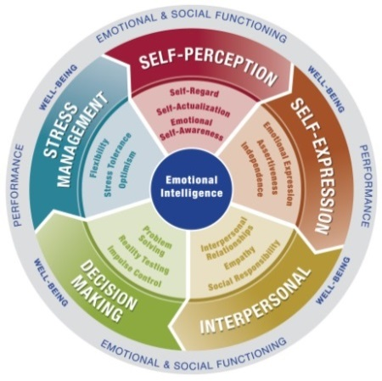

**STRESS MANAGEMENT:** **Stress Tolerance**

**Definition**: Coping with stressful or difficult situations; believing you can influence situations positively.

**Exploring Three EQ-i Insights:**

1. What if your **stress tolerance is too high?** You think you can do it all without realizing that can burn you out. What if it’s **too low?** You feel and can come across like a stressed mess.
2. At all times, including high stress ones, you could be inclined to subdue your emotions. Instead, **use all of your emotions to your advantage**! They all provide useful data when you are aware of them, their causes, and their impact.
3. We all have emotional bank accounts. If you withdraw too much or too often, you’ll go emotionally bankrupt. **Making deposits into your bank isn’t selfish; it’s emotionally healthy**.   
     
   Consider your stress coping techniques as tools in your tool kit. If you have too few or the ones you do have won’t work for various situations, then what? You’re emotionally bankrupt as stress mounts unchecked. The more tools you have, the easier you can manage your stress, so let’s fill an Emotional Intelligence Tool Kit!

**Exercise**: How many de-stressors do you have? List your best ones in your tool kit. Then, **\*** and give the gift of   
your best one to the rest of the class.



**Emotional**

**Intelligence**

**Tool Kit**